

University of Nairobi

B.Sc. Computer Science

Year 2 Sem 2 Project proposal

**MEDICINE TRACKING SYSTEM**

NAME: Mwangangi Neville Kalunda

REG NO: P15/142647/2021

Project supervisor: Prof. Peter Waiganjo Wagacha

A second-year project documentation in partial fulfillment of the requirements for the award of the degree of BSc. Computer Science.

TABLE OF CONTENTS

ABSTRACT 3

1. Introduction. 5

1.1 Background. 5

1.2 Problem statement 7

1.3 Objectives. 7

1.4 Scope of the System 7

2) Literature Review. 8

2.1) Current situation 8

2.2) Role of ICT in Health and Medicine. 9

2.3) The previous existing systems. 10

2.4) What is the need for a medicine allocation system 10

3) System analysis and design 10

3.1) Methodology 10

**3.1.1)** SPIRAL METHOD. 10

**3.1.2)** Sequence: 10

**3.1.3)** Steps to cover: 11

3.2) Implementation 11

3.2.1) requirements elicitation 11

**3.2.2)** Methods used 12

**3.2.3)** Target Audience of requirements elicitation 12

**3.2.4)** How is the information used 12

3.3) Analysis 12

**3.3.1)** Functional requirements 13

**3.3.2)** Nonfunctional requirements 13

**3.3.3)** Pseudo-requirements 14

Uses of the data in the system 14

3.4) ARCHITECTURE OVERVIEW 16

3.4.1 Architecture 16

3.4.2 Technology 16

3.4.3 Application 16

3.4.4 Information Security. 17

3.4.5 Deployment. 17

3.4.6 Services and Components. 17

3.4.7 Processes. 17

3.4.8 Integration. 17

3.5 SYSTEM DESIGN 18

3.5.1 Use cases 18

3.5.2 Activity diagrams 21

3.5.3 Data flow diagrams 25

3.5.4 Database Design 30

3.5.4 User Interface Design 31

4) Software Testing 40

4.1) Testing 40

4.1.1 Test cases 40

5.Conclusion 41

Appendix: REFERENCES 42

ABSTRACT

In many hospitals, the process of allocating medicine and managing patient records still heavily relies on manual procedures. This manual approach involves handwritten prescriptions, physical paper-based medication orders, and manual tracking of inventory and dispensing activities. This method is prone to errors and can lead to inefficiencies and compromised patient safety.

One of the significant challenges with manual systems is the potential for medication errors. Illegible handwriting, misinterpretation of dosage instructions, or confusion in medication orders can result in incorrect administration, potentially causing harm to patients. Additionally, manual record-keeping increases the likelihood of data entry errors, misplaced or lost records, and difficulty in accessing complete medication histories.

Furthermore, the lack of automation makes it challenging to maintain accurate and up-to-date inventory records. Manual systems often struggle to track medication stock levels in real-time, leading to stockouts or overstocking. This can result in delays in patient treatment, increased costs, and potential wastage of medications.

To address these challenges, a medicine dispensing system can be implemented. Such a system would digitize the medication allocation process, incorporating features like electronic prescribing and inventory management. The system would enable doctors, clinical officers, and the hospital director to access patient information, prescribe medications electronically, and monitor medication usage and availability in real-time.

The benefit of a medicine dispensing system is enhanced efficiency by digitizing the medication inventory management.

Additionally, a medicine dispensing system would streamline administrative tasks, allowing hospital staff to spend more time focusing on patient care rather than paperwork. Patient records can be easily accessed, updated, and shared among authorized healthcare providers, facilitating seamless collaboration and continuity of care.

Overall, implementing a medicine dispensing system in hospitals can revolutionize the medication management process, reducing errors, enhancing patient safety, improving efficiency, and optimizing inventory control. By embracing technology and automation, hospitals can provide better healthcare services while prioritizing patient well-being.

Introduction.

1.1 Background.

Health care is an essential need to humans and it should be administered as a right as according to the constitution. It is vital for a government to set up quality health centers that offer quality services to all.

Medicine is the science and art of diagnosing, treating, and preventing disease and illness. The practice of medicine has been an essential component of human culture for thousands of years.

The practice of medicine has changed greatly over time. Medical personnel now have access to a variety of diagnostic equipment and therapies, from sophisticated imaging methods to difficult surgical procedures and specialized pharmacological therapies.

The distribution of medications is a crucial component of all healthcare systems in the globe. The methods used to distribute medicines have changed greatly throughout time.

The delivery of medicines has really advanced giving patients a variety of options. In order to give patients convenient access to over-the-counter (OTC) medicines, prescription drugs, and medical supplies, pharmacies and drugstores have emerged as the principal means of distributing medicines.

The creation of e-pharmacies has been among the most important developments in the distribution of medications. Additionally, e-pharmacies provide a large selection of medication and medical supplies, making it simpler for customers to locate the items they require.

There are a number of specialized medicine distribution techniques in addition to online pharmacies. For instance, hospitals and clinics frequently have their own pharmacy where patients can get the prescription drugs they require for the duration of their stay.

Hospital pharmacies are specialized pharmacies that run inside of medical facilities like hospitals. These pharmacies are essential to patient care since they offer a variety of pharmaceutical services to hospital patients.

Assuring that patients receive the appropriate medication and dosage during their hospital stay is one of the hospital pharmacy's primary responsibilities. Hospital pharmacists actively collaborate with doctors, nurses, and other healthcare professionals to examine patients' medication schedules, keep an eye out for possible drug interactions, and change dosages as necessary.

Hospital pharmacies frequently offer medication services to outpatients as well as inpatients, including prescription fulfillment and medicine dispensing.

Overall, hospital pharmacies are a key component of the healthcare system because they give patients access to vital medication services both during and after their hospital stays. Their knowledge contributes to better patient outcomes and improved healthcare delivery overall by ensuring that patients receive the appropriate medication in the appropriate dosage at the appropriate time.

1.2 Problem statement

The current manual medicine allocation and record-keeping processes in hospitals pose significant challenges, leading to inefficiencies and potential errors. The absence of an automated medicine dispensing system exacerbates these issues and calls for an urgent solution. The problem at hand is the lack of a streamlined and efficient system that can digitize the medication allocation process, improve accuracy in record-keeping, and enhance communication among hospital staff. This problem statement aims to address the need for a comprehensive medicine dispensing system that can overcome the limitations of manual procedures and provide a reliable, safe, and efficient approach to medication management in hospitals.

1.3 Objectives.

This project aims to design a system that could:

* Digitize record keeping.
* Have efficient inventory management.
* Digitize medicine allocation

1.4 Scope of the System

The system focuses on the allocation of medicine to the patients. The users will be the patient, clinical officer, doctor and hospital director. The data will include biodata of both patient and medical practitioners, medicine and their types, treatment and diagnosis history and allocation history.

2) Literature Review.

2.1) Current situation

Currently the government has given licensing to 14193 medical facilities that are widespread all over the country (According to the Kenya Master Health Facility List). These medical facilities may have been set up either by the government, through the community, or through professional health practitioners.

The increasing demand for healthcare services is one of the biggest obstacles facing the dispersion of medications today. There is a rising need for drugs and medical equipment as the population ages and chronic diseases grow more common. It is challenging to keep up with the demand for medicine dispensing as a result of the burden this demand is putting on healthcare systems and pharmacies.

The creation of generic drug counterfeits is another issue. Many nations have put more stringent rules and quality control systems in place to make sure that medicines are authentic and secure in order to tackle this issue.

The price of medicines is a factor that has an impact on how pharmaceuticals are dispensed. Patients may find it challenging to finance the necessary therapies since some medications can be too expensive. This is especially true in nations with privately funded healthcare systems or with constrained insurance coverage.

Many pharmacies and healthcare organizations are implementing cutting-edge dispensing techniques and new technologies to address these issues. For instance, e-pharmacies are increasing in popularity and give patients the ease of ordering medication online and having it delivered to their homes. Patients can remain on top of their drug regimens with the aid of smart pill bottles and medication reminder applications, both of which are spreading in popularity.

Overall, there are many creative solutions being developed to increase patient access to pharmaceuticals and medical supplies, despite the difficulties and problems facing the distribution of medications. The field of pharmaceutical dispensing is expected to advance even more as technology develops, improving patient outcomes and healthcare delivery as a whole.

2.2) Role of ICT in Health and Medicine.

In recent years, health has digitized some of its functions. Some hospitals practice a digitized form of data handling through the creation of accounts in their databases. Examples of such hospitals are Aga Khan and Nairobi West. These hospitals encourage patients to sign up at their hospitals before being treated.

According to the Kenya Digital Master Plan, the government is planning to create data centers(hubs), install high speed optical infrastructure to health facilities, digitize 5 billion governmental manual records etc. These plans will create an opening for the digitization of the health sector. Medical equipment’s have seen very significant improvements due to technology but on the other hand becoming very expensive to the patients.

2.3) The previous existing systems.

In the near past, data was mainly handled physically and brought about bulkiness in its management. Accumulation of total sales and revenue were mainly done annually with the reports. Only some of the private owned hospitals inculcated digital data management in their operations.

2.4) What is the need for a medicine allocation system

* There is a need to track medicine handling in a hospital since medicine is scarce.
* There is a need to manage medicine so that it can be enough for all patients.
* There is a need to track returns on medicine revenue.

3) System analysis and design

3.1) Methodology

**3.1.1)** SPIRAL METHOD.

This is a modern method that combines elements of prototyping and linear models. The linear sequences of activities are to be executed in a staggered fashion. The sequence will be in constant loop in developing a part of the application. Each increment may be incorporated with prototyping or complete development of the module.

**3.1.2)** Sequence:

* Requirements
* Analysis
* Implementation and testing
* Evaluation
* Communication

The first increment will entail the core product (the database and the users) addressing the core needs.

This method will prove effective since the program cannot be implemented in one go.

**3.1.3)** Steps to cover:

* The first time will cover the elicitation and requirement specification.
* A prototype may be developed covering the core elements obtained during the elicitation.
* Each pass through the planning region will cause a change in the project plan.
* Feedback and communication will result in plan revision and adjustment.

3.2) Implementation

3.2.1) requirements elicitation

Purpose of requirements elicitation

* To get explanations, understand better and explore opinions.
* To get ideas of designing the medicine tracking system.
* To get the reviews of previous medicine tracking systems and how it can be improved.
* To get the feel of the previous medicine tracking system.
* To know the data collected by the system.

**3.2.2)** Methods used

* Interviews.
* Task observations
* Document analysis.
* Generating scenarios and use cases.

**3.2.3)** Target Audience of requirements elicitation

* Doctors of different hospitals.
* Citizens/patients of different hospitals.

**3.2.4)** How is the information used

* It is used to design a simpler vetting process.
* It is used to get suggestions of where the system can be efficient.
* To raise the need for an efficient medicine tracking system.
* To know the data to be collected, its size and how it is stored whether physically or cloud.

3.3) Analysis

The doctor is the main prescriber of medicine in a hospital. Clinical officers can also prescribe medicine and they do so in collaboration with doctors. They are mostly involved with patient care and ensuring that the trend of treatment of a patient is positive. The hospital director is the administrative lead in making financial decisions in the hospital. He plans strategies that enhance the hospital’s growth. Anything in terms of restock, employing new doctors, etc. will be under him.

The system is to be built as a database with several users (patient, doctor, clinical officer ,director). Each user has its own features on how they access the database. They all enter their login information in a common portal from which they are redirected depending on the level. The director will be able to change core entities in the database e.g. medicine details. The doctor as well as the clinical officer will be adding allocations and the patient will be able to see his records.

The following requirements should be included in the operation of the application.

**3.3.1)** Functional requirements

The functional requirements for a patient:

* See allocation and treatment history.

The functional requirements of the doctor/clinical officer:

* Allocate medicine to patients.
* Create patient accounts.
* View patient details.
* View previous allocations and treatments.

The functional requirements for the director:

* Update patient data.
* Update medicine stock.
* View reports on medicine analysis.
* Add new doctors

**3.3.2)** Nonfunctional requirements

This section shows any other requirements that the system should hold. The system should have:

* Security – There should be a high level of security of the data held by the system. Only authorized personnel (the director) can access the secured page on the system.
* Performance and response time – The system should have a high-performance rate when executing the user's input and should be able to provide feedback within a short time.
* Error handling – An appropriate error message should be displayed to guide the user on how to recover from an error in case they run into one.
* Availability – The system should always be running for 24 hours, 7 days a week.
* Ease of use – The system should be user-friendly and have a graphical user interface (GUI).
* The system should remind patients to pick up medicine.
* The system should notify both the doctor and director of an upcoming shortage
* The system should track returns on medicine.
* The system should be able to offer alternatives on any medicine that is lacking in stock.

**3.3.3)** Pseudo-requirements

* The system should be cloud based
* There should be session timeouts.

Uses of the data in the system

The data collected in this system can be used to see:

* Revenue of the medicine sold/allocated.
* The cases in which a specific medicine is given
* How a patient fares during a period of time through how much medicine he/she is taking.
* Which type of medicine is sold the most.
* Which medicine should be regularly restocked.
* Which medicine type is sold the most.

3.4) ARCHITECTURE OVERVIEW

3.4.1 Architecture

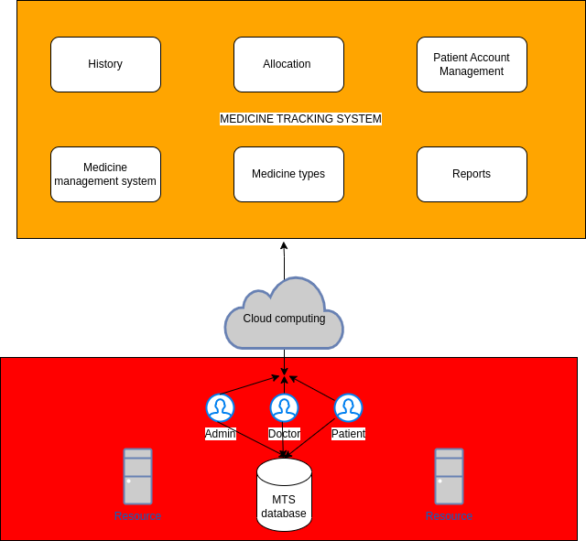

3.4.2 Technology

The system is a web application built on php that allows users to interact using a web based approach that can connect the database through a cloud service.

3.4.3 Application

The medicine tracking system is a web application that enables the public

and its staff access the system and its services for free.

3.4.4 Information Security.

There is need to keep the organization’s data safe and therefore the medicine tracking system has implemented the use of account-based permissions to filter out users based on the security policy established.

3.4.5 Deployment.

The system requires some sort of hardware and software components on which it will be deployed. Therefore, considering hardware, there is need for a computer, motherboard, CPU, RAM, Keyboard and mouse, and on the software part, there is need for acquiring and installing the operating system on which the system will operate best in.

3.4.6 Services and Components.

The system provides several services such medicine allocation services, patient handling services, medicine stock keeping and so on.

3.4.7 Processes.

There are processes that need to be followed in order to create a systematic way of operation in the system. For example, there should be a process for registering a new patient into the system and adding them to the system database. Other processes include adding new medicine, updating medicine and patient details and so on.

3.4.8 Integration.

The various components of the medicine allocation system have been integrated with one another allowing the organization to achieve its goals. For example, when a user wants to access the history of allocation, he/she has to go through the login process in order to be allowed to see that data.

3.5 SYSTEM DESIGN

3.5.1 Use cases

Use cases are an essential part to the design of any system. They help in minimizing errors and making sure that the requirements given by the user are fulfilled. In the operation of the medicine dispensing system, the following use cases erupted and afterwards the use case model.

Case 1 (Patient checks for the next refill)

* Patient logs in.
* Patient clicks on data from menu
* Patient checks the listed date

Case 2 (Patient checks his previous allocated medicine)

* Patient logs in.
* Patient clicks on history from menu
* Patient checks the listed history

Case 3 (Patient checks his profile details)

* Patient logs in.
* Patient clicks on profile from menu
* Patient checks the listed details.

Case 4 (Patient checks his previous allocated medicine)

* Patient logs in.
* Patient clicks on history from menu
* Patient checks the listed history

Case 5 (Doctor/clinical officer checks the available stock of medicine)

* Doctor logs in.
* Doctor clicks on stock from menu
* Doctor checks the available listed medicine

Case 6 (Doctor/clinical officer creates new allocation)

* Doctor logs in.
* Doctor clicks on allocate from menu
* Doctor clicks entry on the top
* Doctor fills details of the allocation
* Doctor submits

Case 7 (Doctor/clinical officer checks previous allocations)

* Doctor logs in.
* Doctor clicks on allocate from menu
* Doctor clicks history on the top
* Doctor checks the listed allocations

Case 8 (Doctor/clinical officer creates new patient account)

* Doctor logs in.
* Doctor clicks on Patient from menu
* Doctor clicks create on the top
* Doctor fills details of the patient
* Doctor submits

Case 9 (Doctor/clinical officer finds patient details)

* Doctor logs in.
* Doctor clicks on patient from menu
* Doctor clicks find on the top
* Doctor fills patient email
* Doctor submits
* Doctor checks the listed details.

Case 10 (Director checks reports.)

* Director logs in.
* Director clicks on revenue from menu
* Director checks on the drawn graph

Case 11 (Director edits patient details.)

* Director logs in.
* Director clicks on patient
* Director fills in patient email
* Director clicks submit
* Director edits the patient’s details.
* Director clicks update

Case 12 (Director creates new medicine.)

* Director logs in.
* Director clicks on medicine
* Director clicks new medicine at the top
* Director fills in medicine details
* Director clicks submit

Case 13 (Director updates medicine.)

* Director logs in.
* Director clicks on medicine
* Director clicks update medicine
* Director fills in medicine name
* Director fills in medicine details
* Director clicks update

3.5.2 Activity diagrams

* Patient activity diagram

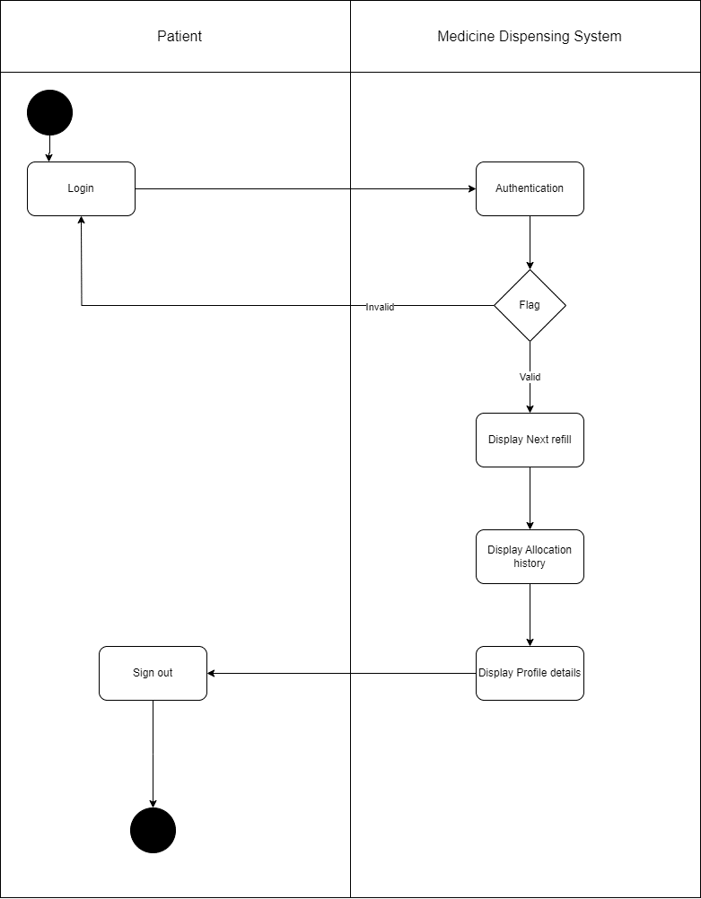

* Doctor Activity Diagram

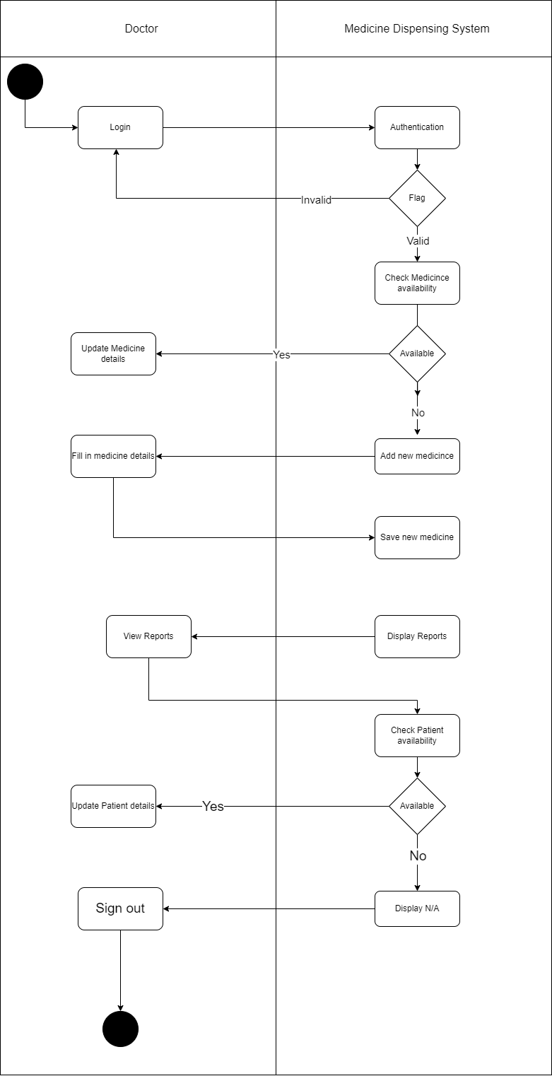

* 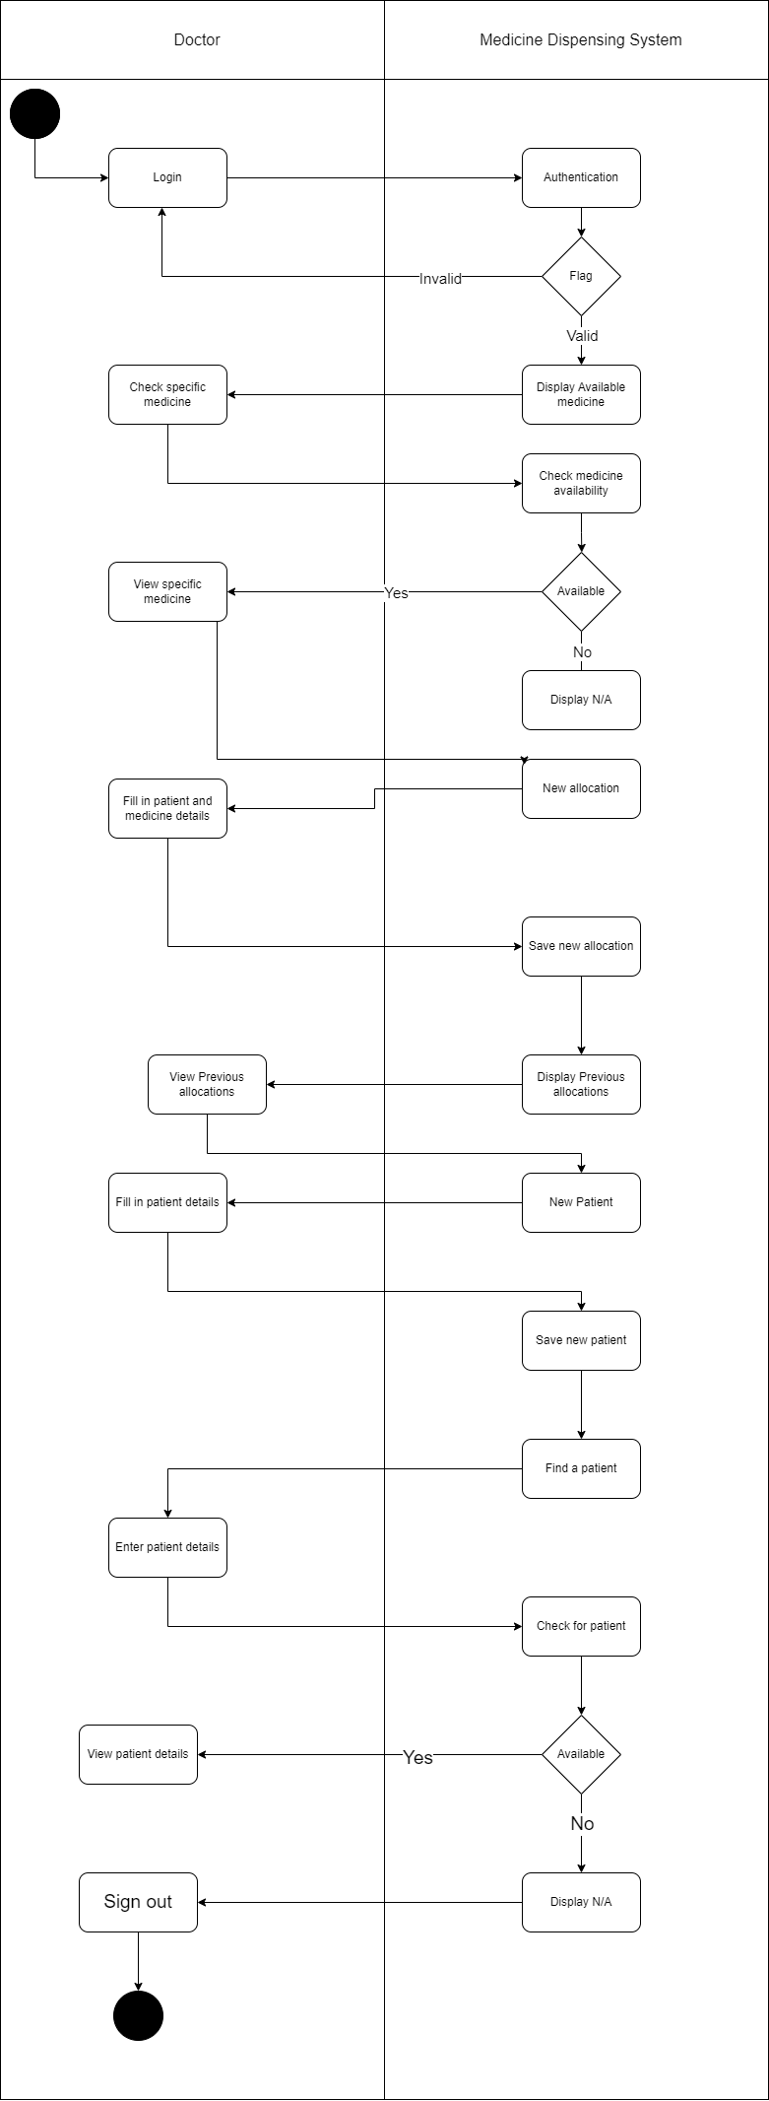Director Activity Diagram

3.5.3 Data flow diagrams

The system is built on systems and processes that helps it operate in their daily work. Data flow diagrams are a way for the system to analyze and improve efficiency as it visually maps the system to provide a broad view that is easily digestible as compared to using words. The data flow diagram is derived from a context diagram which is simply composed of the main system. The contextual diagram is then expanded to create the level 1 DFD that provides more details, and later on can be further expanded to the level 2 DFD for more details on the level 1 DFD.

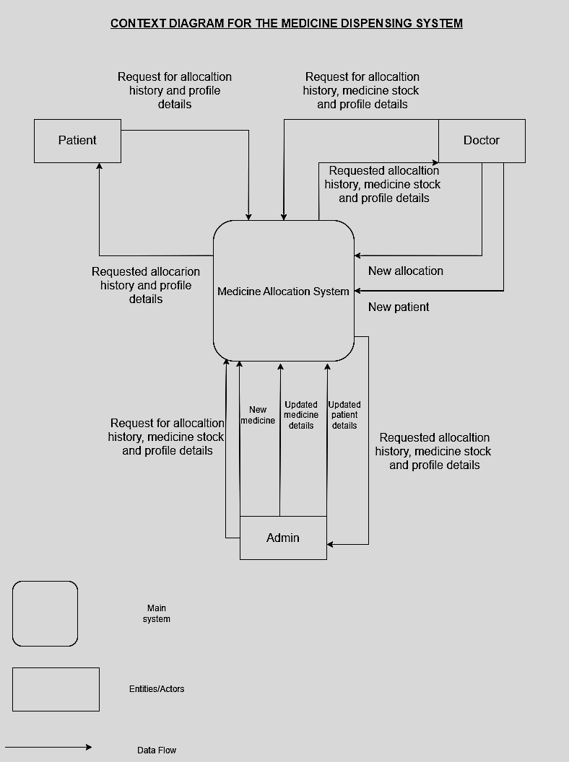

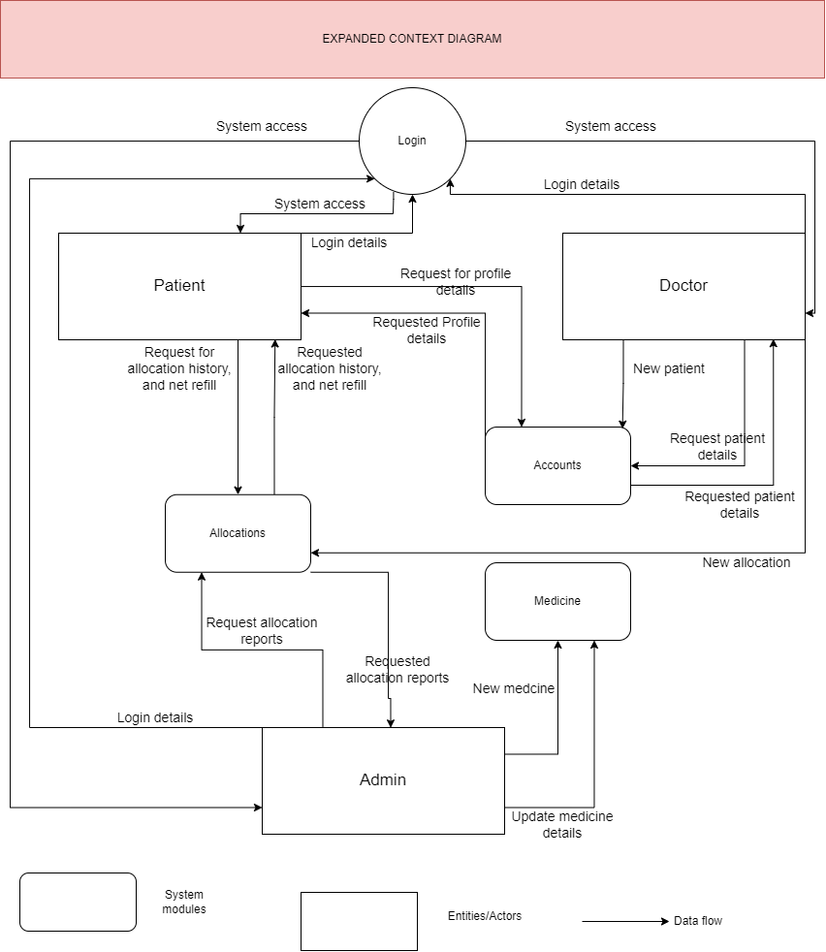

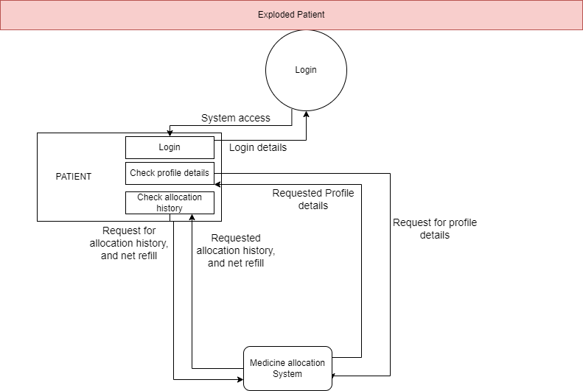

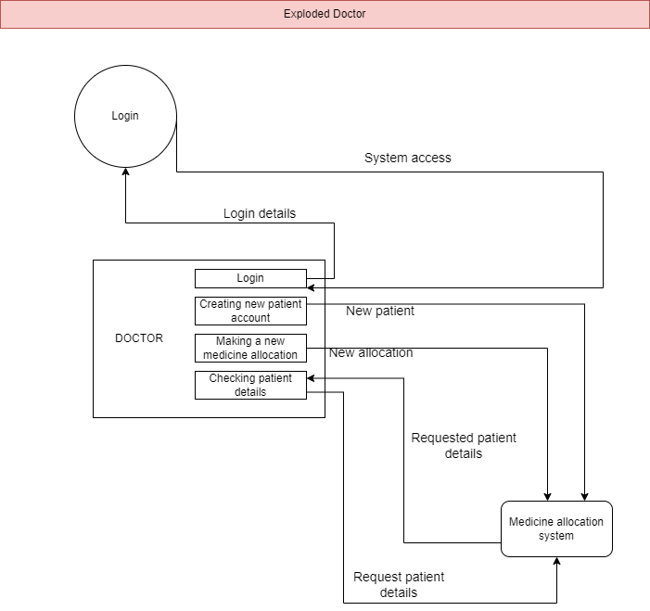

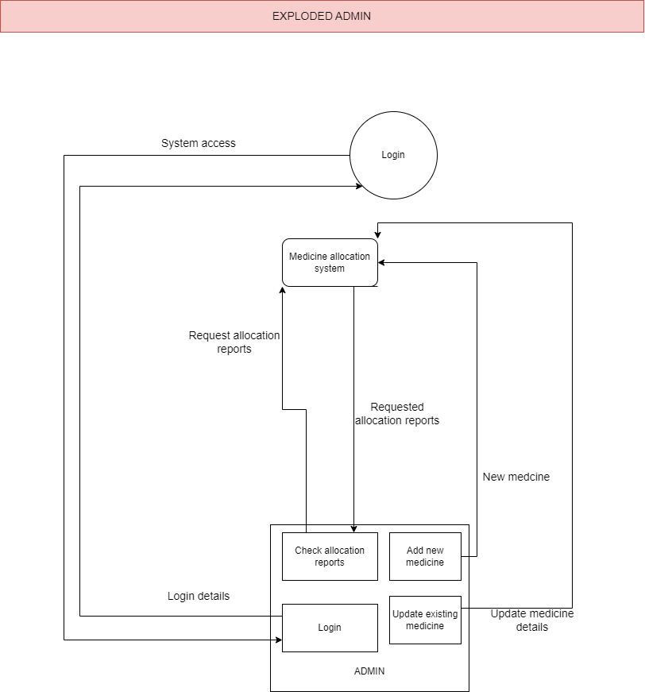

3.5.4 Database Design

The KICD database will hold all the data that is transmitted. The design will look as follows:

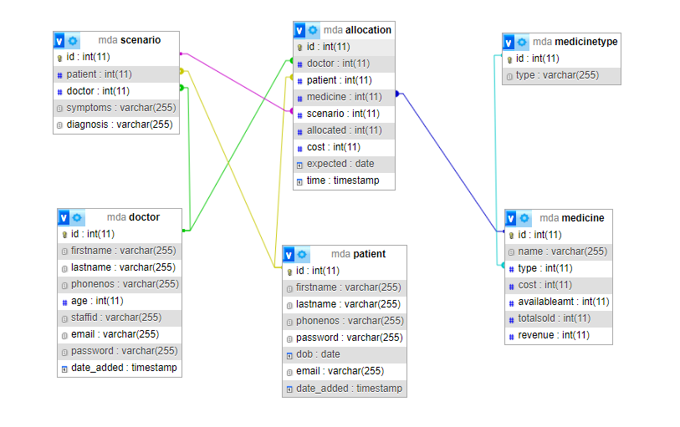The tables of the system are as follows:

1. Patient

This table contains data concerning the patients accessing the database. For any patient that is allocated a medicine, he/she must have an account created by a doctor. The table also contains a patient’s biodata that is essential in analysis.

1. Doctor

The table contains the information about a specific doctor.

1. Medicine

The tables contains all the medicine available in a particular hospital.

1. Medicine type

This table explains the medicine table further in that it puts some medicine in categories. Not all medicine must have a category.

1. Scenario

This table explains the patient case/diagnosis upon allocating a medicine. This ensures that medicine is allocated for the right purpose.

1. Allocation

This table explains which medicine was allocated, the dosage given and the revenue gained from that specific allocation.

3.5.4 User Interface Design

The user interface is where the users will be able to interact with the system.

The login page for all modules

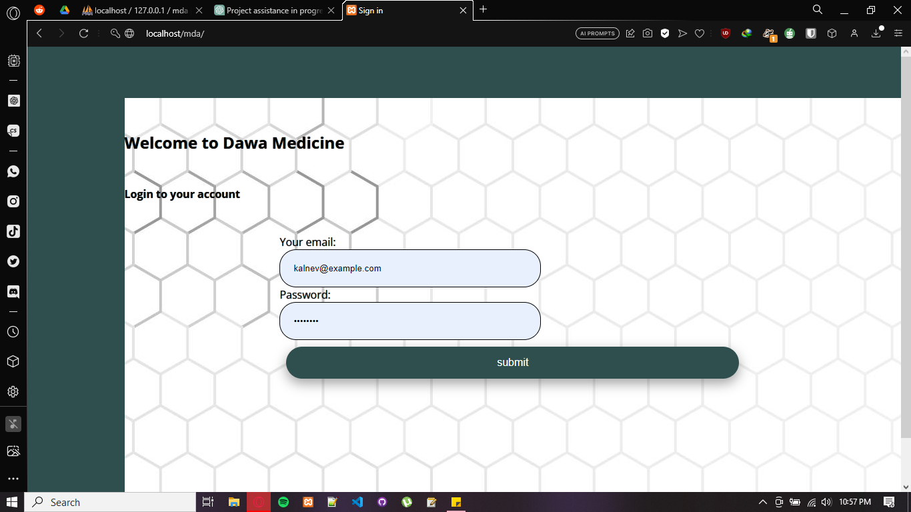

From here the patient module will look as follows:

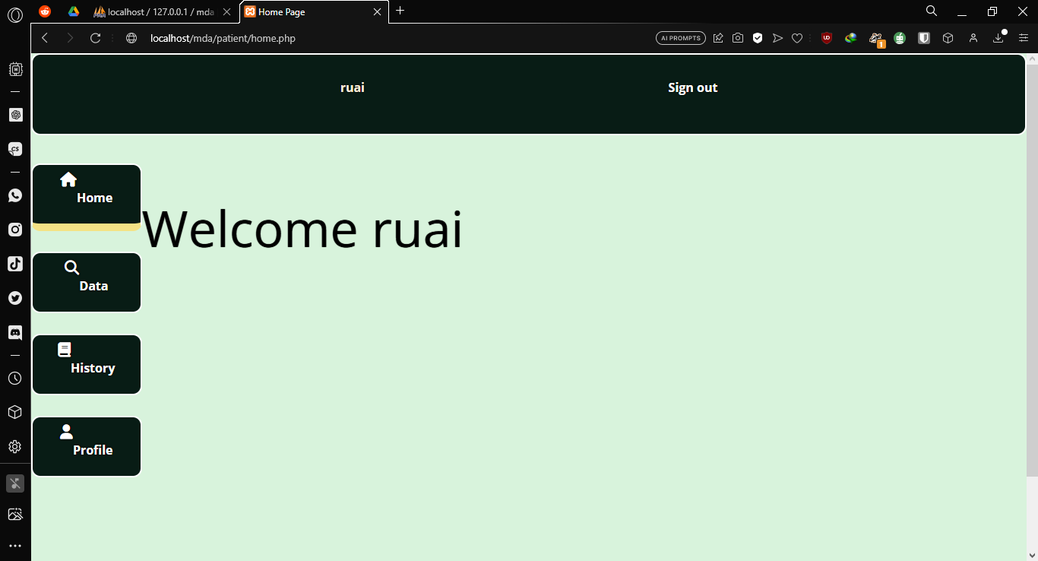The home page of the patient module

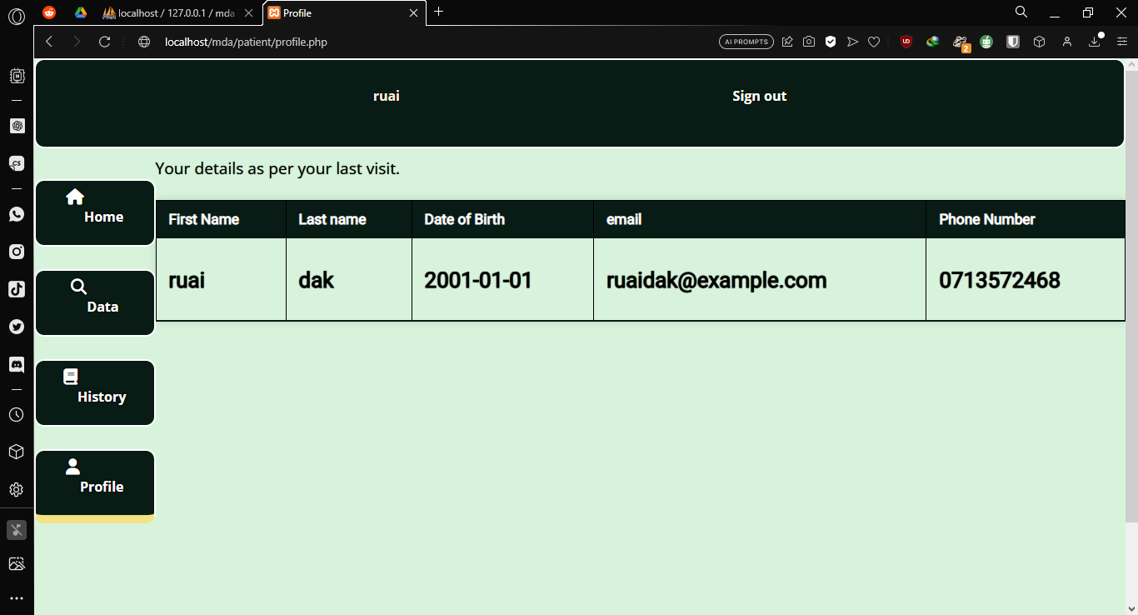The Profile details are displayed here.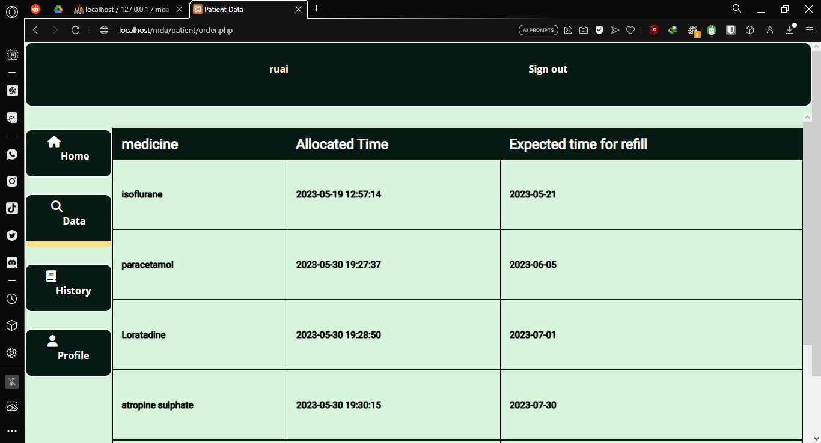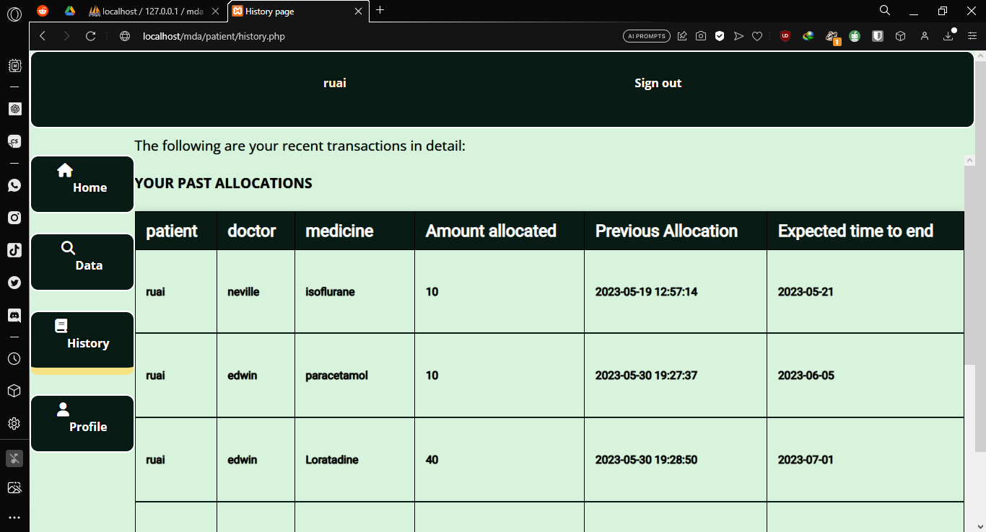

The patient can see his past allocations and the next refill from the images shown

The doctor module will look as follows:

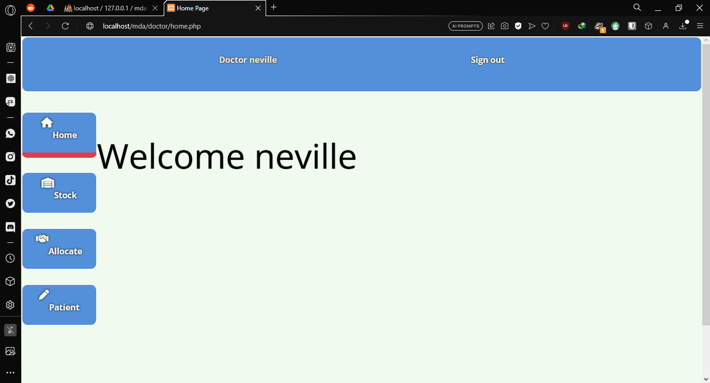

Home

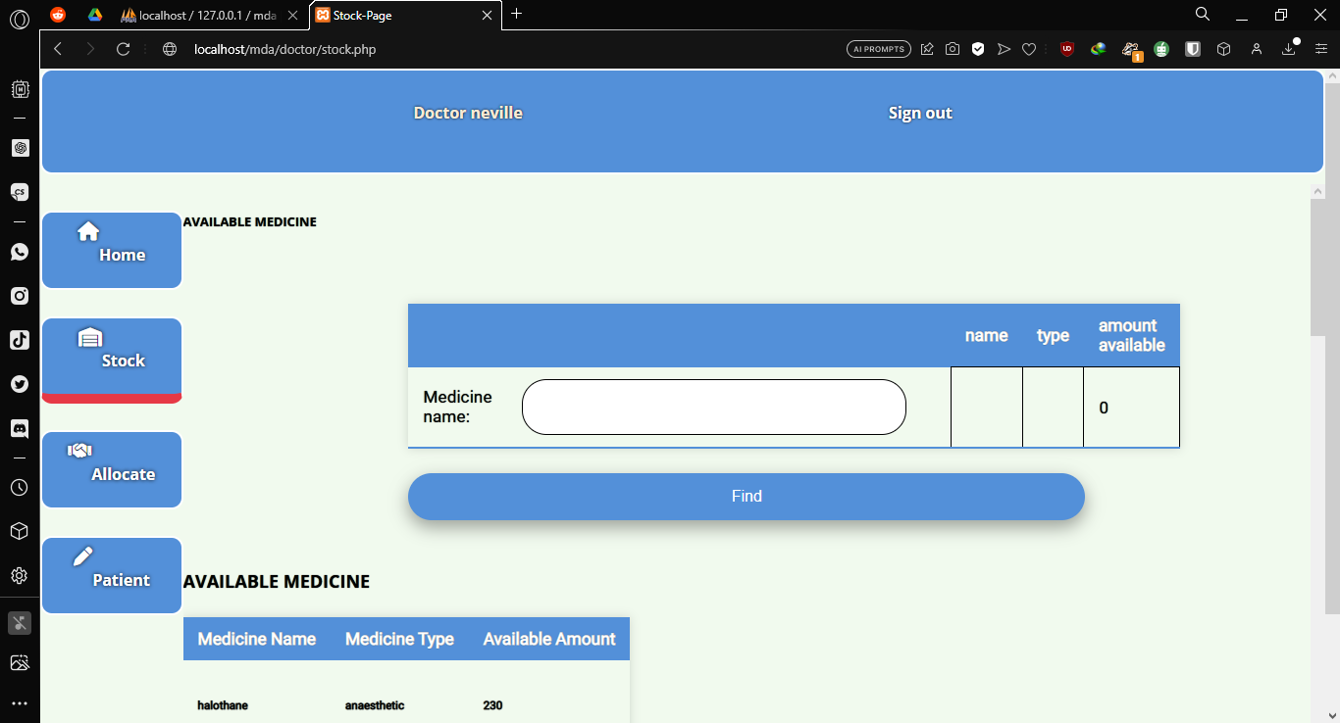

The doctor/clinical officer will check for the available stock here.

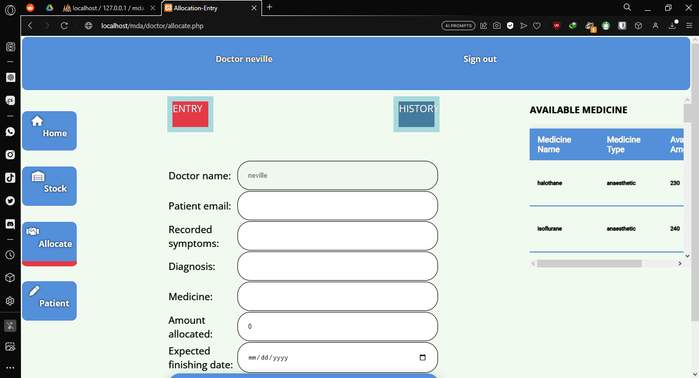

The doctor/clinical officer will allocate here and press submit.

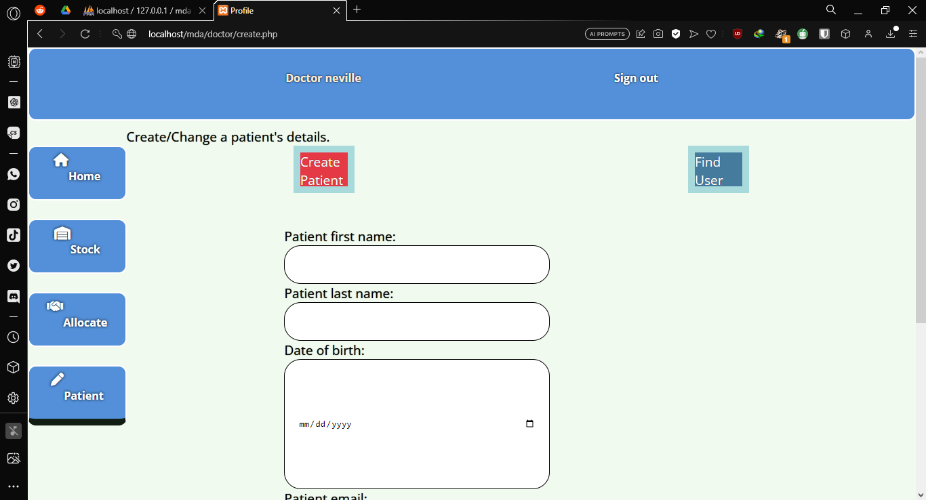

The doctor will create new patient accounts from the above image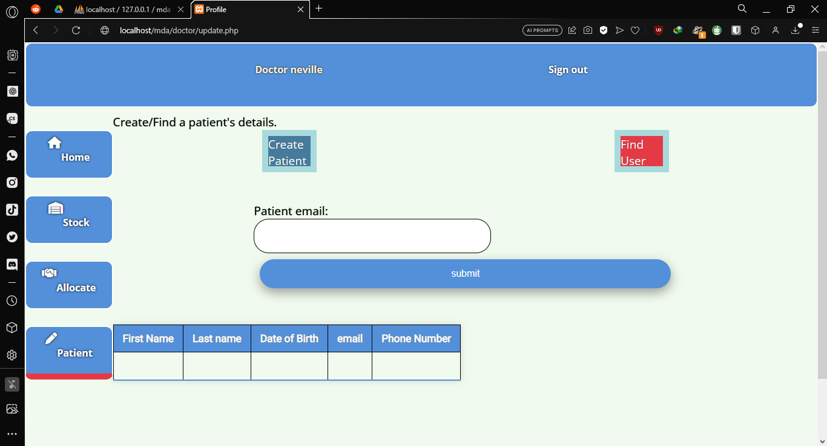The doctor/clinical officer is able to find patient details here.

The clinical officer will have similar features to the doctor except when looking for the patients who require medicine in a period of time.

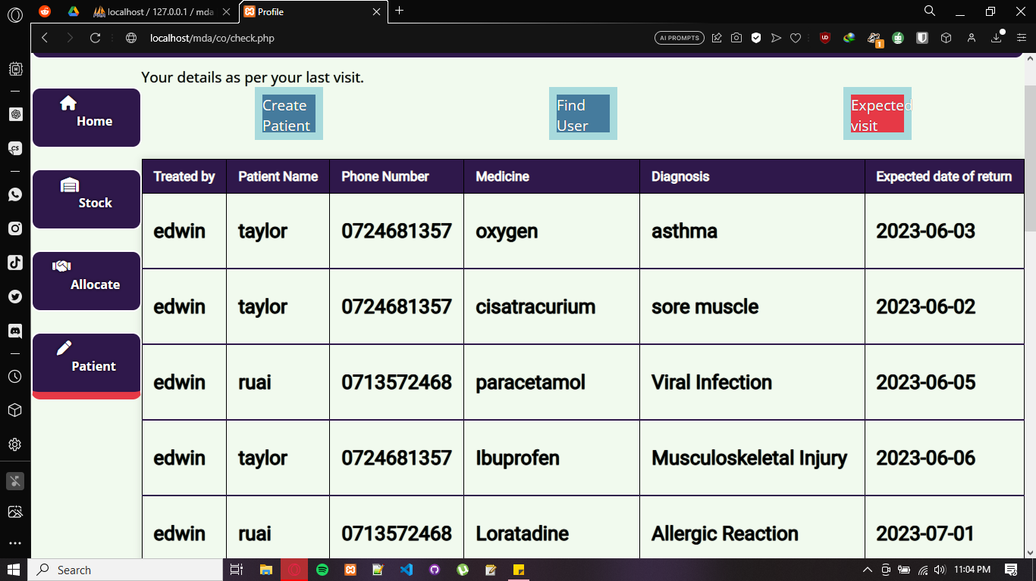

The director module will look as follows:

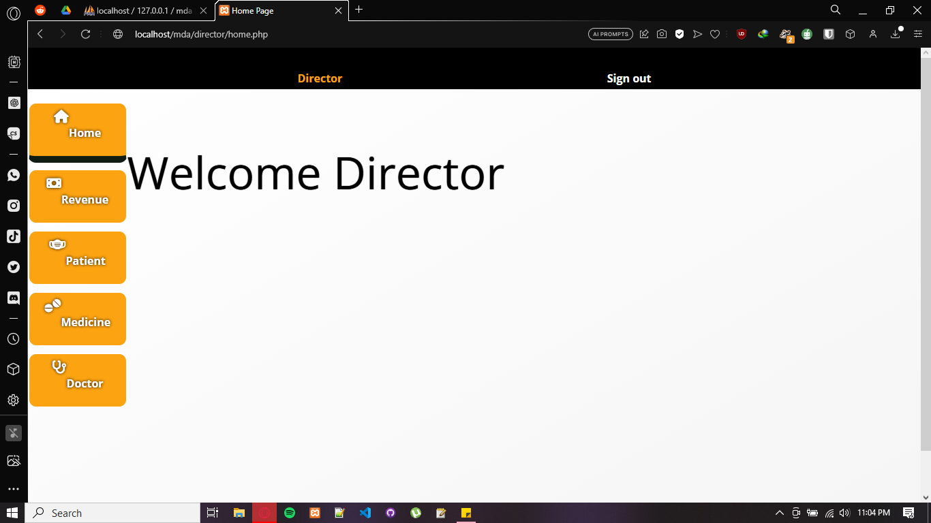

Home

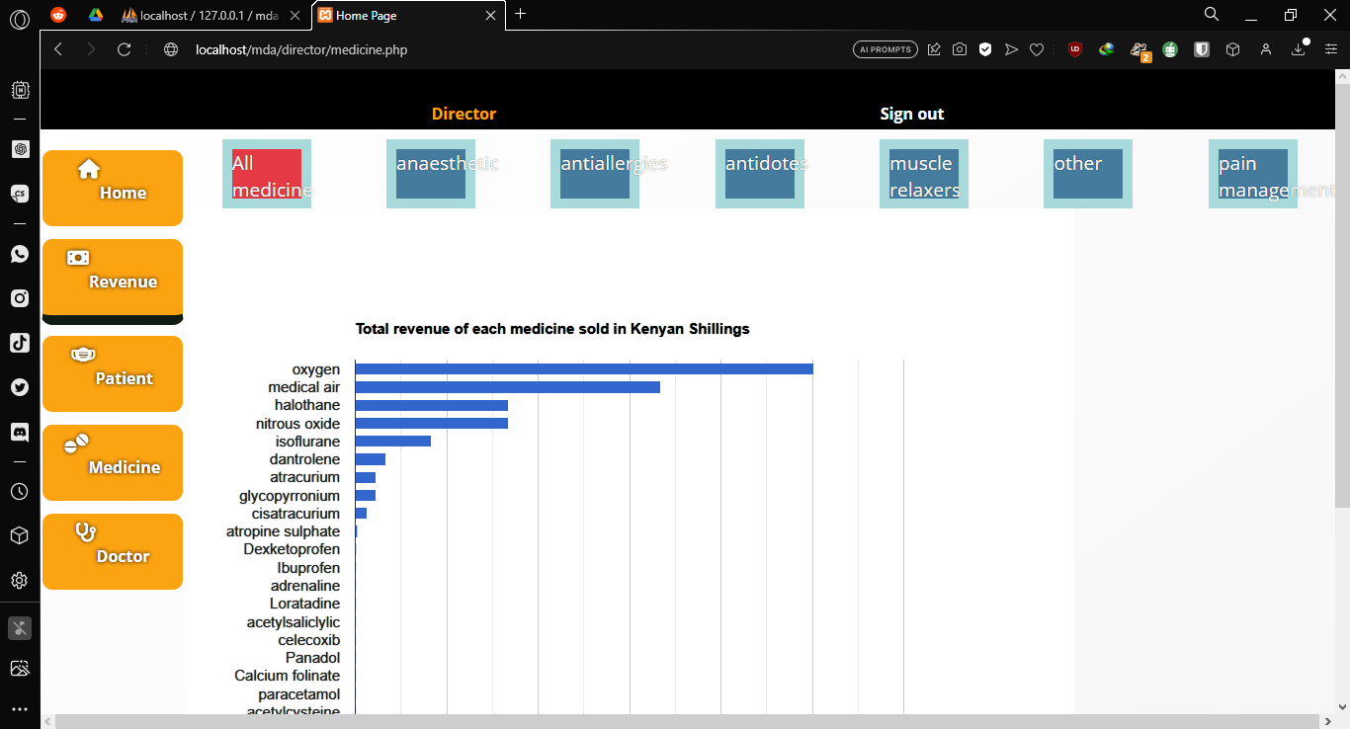

The director can look at various reports from here in the picture above.

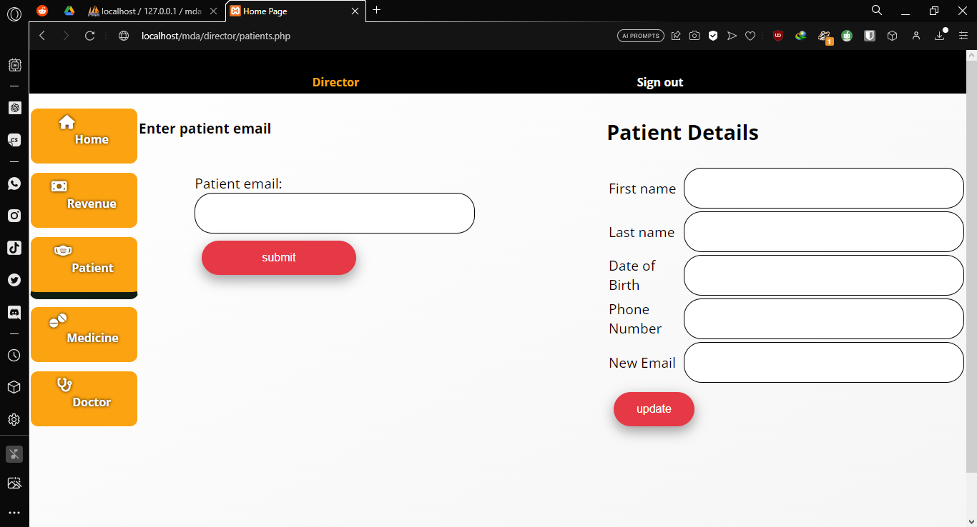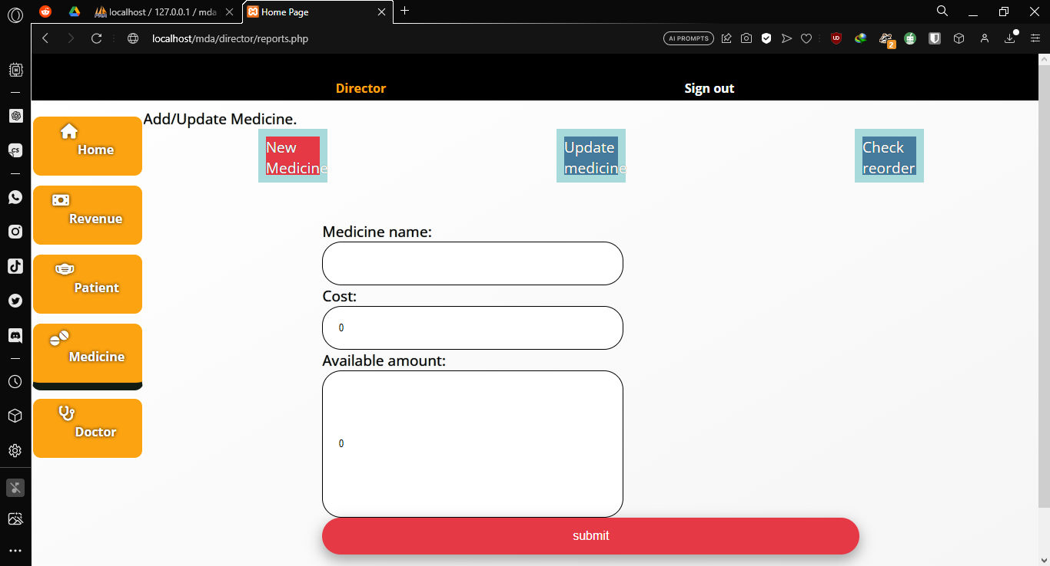

Create new medicine and updating patient details.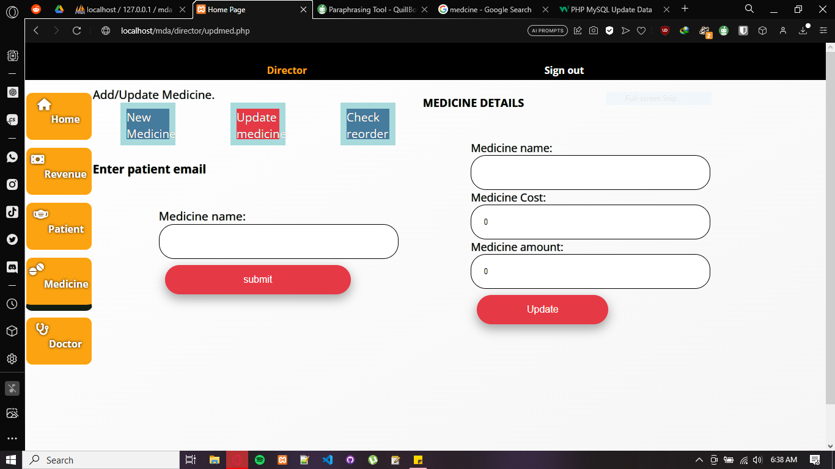

The director can update medicine details here.

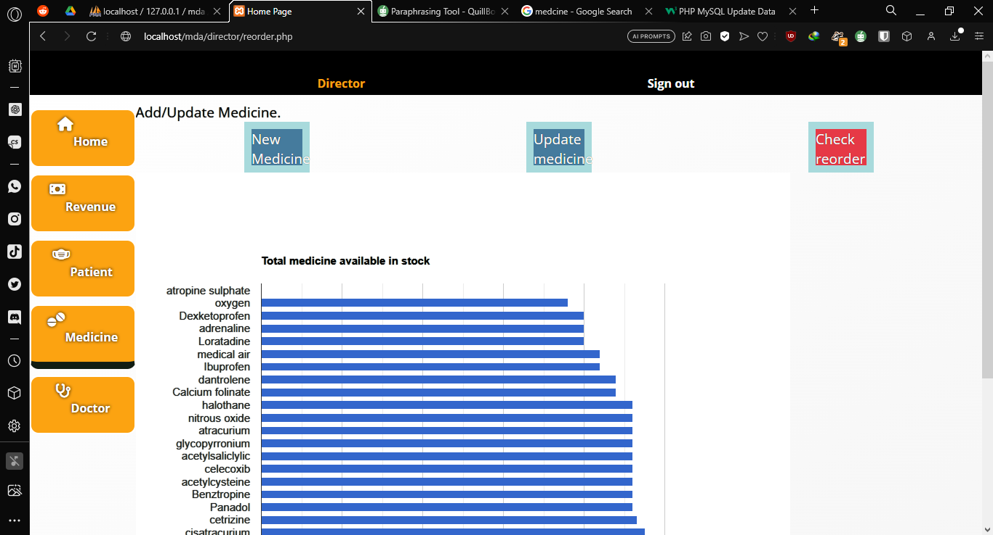

The director can check what medicine to reorder here.

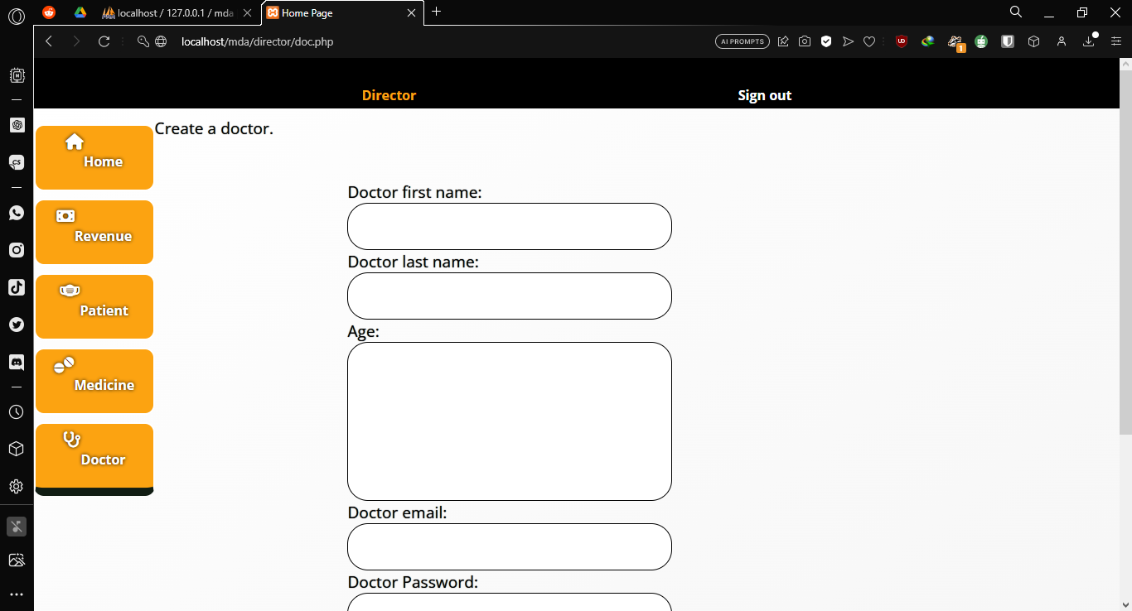

The director can create a new doctor account here.

4) Software Testing

4.1) Testing

This is done to guarantee that the proposed system's functional and non-functional requirements were met. Additionally, it is done to ensure that the system authenticates and verifies the users accessing it and denies unauthorized staff access.

Component testing is carried out to ensure that the system components are appropriately coded and operate in accordance with the desired functionality.

4.1.1 Test cases

Case 1 (Patient fills wrong login)

* Patient writes login details
* Patient clicks submit
* Server says invalid login details

Case 2 (Doctor/clinical officer inputs wrong medicine)

* Doctor logs in.
* Doctor clicks on stock from menu.
* Doctor fills in search with medicine name.

Case 3 (Doctor/clinical officer creates invalid allocation)

* Doctor logs in.
* Doctor clicks on allocate from menu
* Doctor fills details and submits
* Server responds with wrong details
* Doctor submits

5.Conclusion

There were some complications during the research and development of this system:

* PHP is a limited language compared to other backend languages e.g., for server responses, one cannot manually edit on PHP.
* Majority of the doctors I interacted with had experience of a digitalized medicine dispensing system. They are used to the manual hand written.
* One of the pages(director/Update medicine) was not consistently working.

REFERENCES

* Kenya Digital Master plan
* Kenya Community Health Strategy 2020-2025
* Ministry of Health website [https://www.health.go.ke](https://www.health.go.ke/)
* The Health Act No.21 of 2017
* Action for transparency Health structure and levels of hospitals <https://actionfortransparency.org/kenyas-health-structure-and-the-six-levels-of-hospitals-roggkenya/>
* <https://web.pharmacyboardkenya.org>